Press Release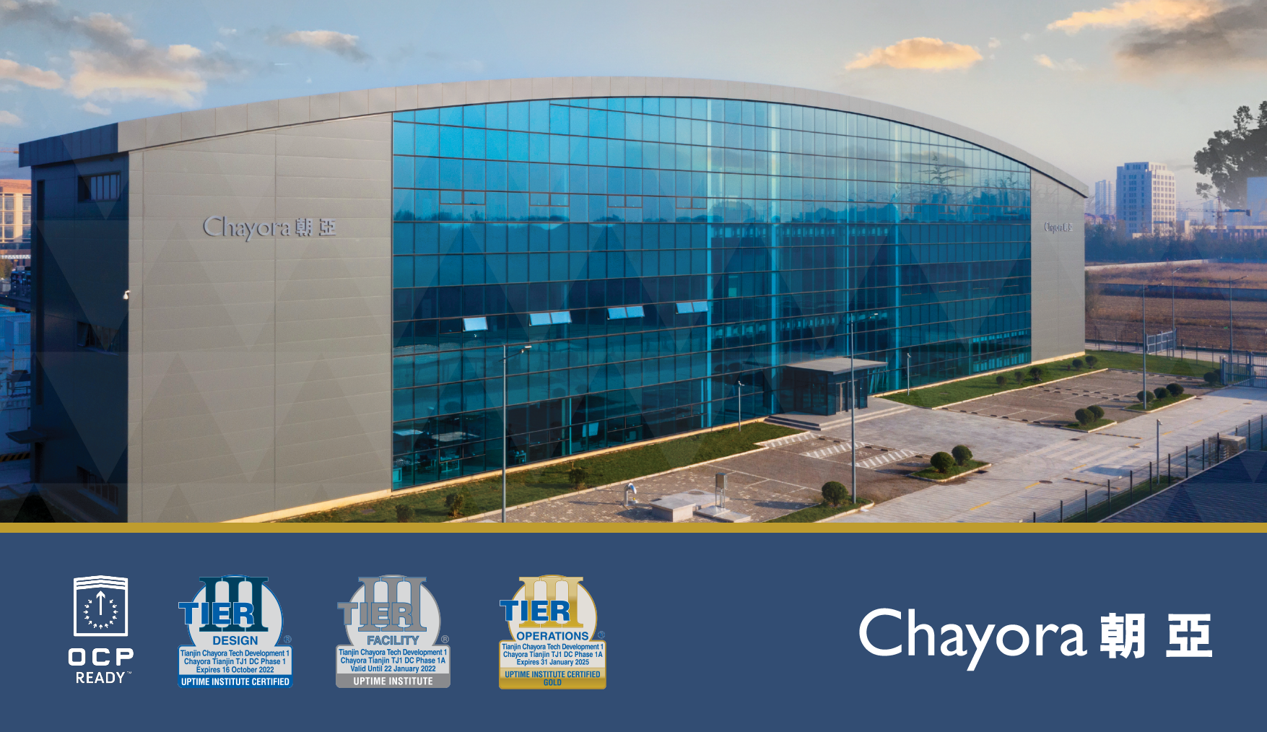
Chayora’s Tianjin Datacentre, China awarded Uptime Institute Tier III Gold Certification of Operational Sustainability

Hong Kong – March 16, 2022: Chayora, an international digital infrastructure investor, developer and operator of hyperscale data centre campuses in China, has been awarded the Tier III Gold Certification of Operational Sustainability (TCOS) for its Tianjin campus by Uptime Institute.
Uptime Institute’s Tier Standard: Operational Sustainability recognizes that Chayora’s Tianjin datacentre realized the full uptime potential of the Tier III installed infrastructure. The Gold Certification of Operational Sustainability is a points based assessment, when a data center group meets the basic requirements to keep their site operational across the defined ranges, they are awarded a Bronze TCOS. Sites that have anticipated a wider range of conditions or production possibilities planning to accommodate those situations when they occur can achieve either Silver or Gold based on how much above the minimum is scored. Chayora’s Tianjin site illustrated exceptional management & operations and building characteristic behaviours and low site risks were observed. Adherence to these behaviours and mitigation of site risks have been proven to minimize opportunities for human error – the number one cause of data centre downtime.
Chayora’s Tianjin and Shanghai campuses, when fully developed, will jointly provide capacity of more than 200MW of IT load and over 35,000 racks for customers.

“Chayora demonstrated a high level of commitment to effective operations with their Tier III Gold Certification of Operational Sustainability,” said Christopher Brown, Chief Technical Officer, Uptime Institute. “Chayora did an admirable job preparing for their remote certification, and making sure that everything went smoothly, completing their gold certification.”
TCOS certification includes additional assessment criteria around building features and infrastructure, and is a more comprehensive assessment of the ability of data center sustainability. Operations Director, Chayora, Tiger Zhao said: “I am extremely proud of my team who have been able to satisfy the challenging test regime of Uptime Institute and achieve this important certification. This certification demonstrates the world class standards to which we operate the Chayora Tianjin campus.”
“Chayora’s Tianjin campus offers assured scaleability to international and domestic clients seeking the reassurance of an operator adhering to objective world class standards and this offers our datacentre customers in the Greater Beijing area excellent standards of service and capacity.”” said Jonathan Berney, Co-Founder and COO, Chayora. “This certification builds on our existing awards with Uptime Institute Tier certification and as the first OCP Ready™ campus in Northern China.”
# # #
About Chayora
Chayora Limited, headquartered in Hong Kong, is wholly-owned by Chayora Holdings Limited, a Cayman Island-based company. Chayora develops hyperscale, world-class designed and operated, scalable data centres and data centre campuses in China. Chayora serves global Fortune 500 companies and premium Chinese data centre operators offering cloud services, ICT services, financial services or other services offerings dependent on intensive, high quality data centre infrastructure in China.

For more information about Chayora, visit www.chayora.com.

