**Press Release**

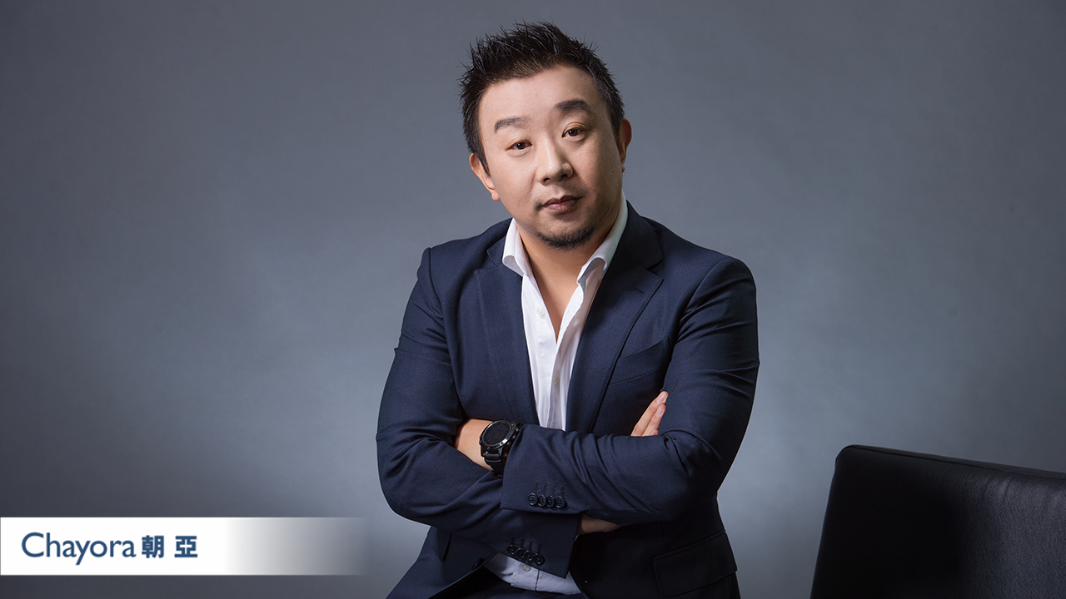

***Chayora strengthens its China Executive Team by appointing a new Executive Vice President for Sales, Mainland China***

*Hong Kong: July 4th 2022:* Chayora, an international digital infrastructure investor, developer and operator of hyperscale data centre campuses in China, today announces a key addition to its Executive Team with the appointment of Leo Zhao as EVP, Sales for Mainland China, with immediate effect.

Leo is a highly experienced ICT sales professional and will lead the recently expanded domestic China sales team to deliver growth into the world’s fastest growing datacentre and digital market. Leo’s appointment follows the recent appointments of Richard Zheng and Taurus Luo as sales VP’s. Chayora is currently constructing the next phase of its Tianjin campus and its new campus in Shanghai will have its first data centre Ready for Service in late 2022. Chayora’s Tianjin and Shanghai campuses, when fully developed, will provide capacity of more than 200MW of IT load and over 35,000 racks for customers. Leo has extensive leadership experience as well as new business and account growth expertise which he will use to lead the China sales team as Chayora supports the explosion of big data processing and digital infrastructure requirements in China.

Leo expressed his excitement at joining and contributing to the entrepreneurial fast growing Chayora business, commenting “*It’s my pleasure to join Chayora. I spent more than 23 years in the Chinese enterprise market and have successfully supported their growth. I have learned a lot on the way from some great organisations and experiences and plan to use what I have learned to make Chayora the next big thing to happen in the industry.  I believe with our smart, strategic and hard working approach, we will be the top player in the Chinese IDC market.”*

*“We are delighted to be able to attract a highly skilled, elite professional in Leo who is bringing Chayora more than 23 years ICT industry sales experience in China, gained at four international companies (Lenovo, IBM, Oracle and LexisNexis). Leo has managed major accounts across government, telecom, banking, energy and utility industries with hardware, software and data service offerings.*” said Oliver Jones, CEO, Chayora.  “*With this exceptional new hire, Chayora is now positioned to deliver extraordinary sales growth..”*

Leo is fluent in Mandarin and English and holds a degree from Beijing University of Posts and Telecommunication in Telecom Engineering.

# # #

**About Chayora**

Chayora Limited, headquartered in Hong Kong, is wholly-owned by Chayora Holdings Limited, a Cayman Island-based company. Chayora develops hyperscale, world-class designed and operated, scalable data centres and data centre campuses in China. Chayora serves global Fortune 500 companies and premium Chinese data centre operators offering cloud services, ICT services, financial services or other services offerings dependent on intensive, high quality data centre infrastructure in China.

For more information about Chayora, visit [www.chayora.com](http://www.chayora.com).