**Press Release**

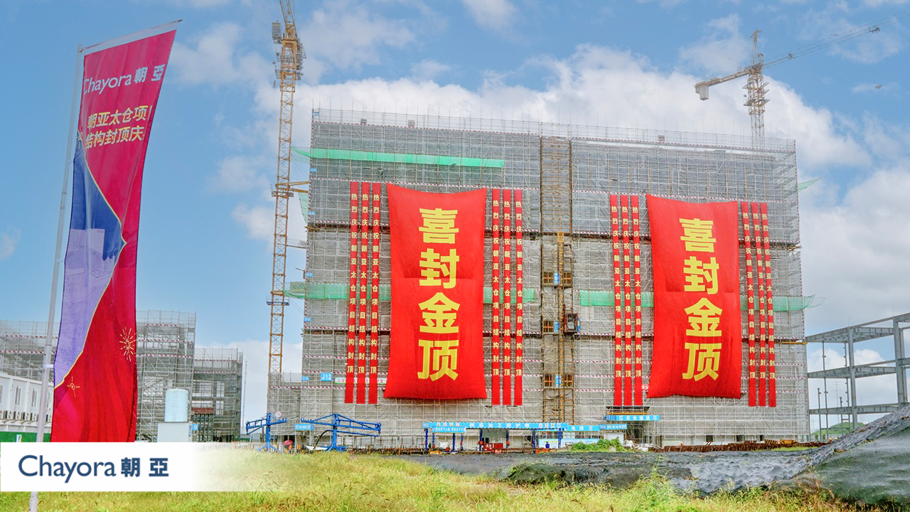

***Chayora Celebrates Shanghai Campus Topping Out and Notable Safety Milestone Achievement***

*Hong Kong: September 29th 2022:* Chayora, an international digital infrastructure investor, developer and operator of hyperscale data centre campuses in China, yesterday celebrated the full structural completion of the first Data Centre on its second campus in Shanghai and an important latest site safety milestone of 400,000 safe person hours.

A formal ceremony was held to mark the completion of the upper structure as Chayora progresses on schedule to achieve Ready for Service status on its new campus in Shanghai at the start of 2023. Yesterday the team celebrated their achievements with a traditional award ceremony for staff and contractors, ahead of a larger customer campus launch event in November. This is the second campus to be delivered by Chayora, whose Tianjin and Shanghai campuses, when fully developed, will provide capacity of more than 200MW of IT load and over 35,000 racks for customers.

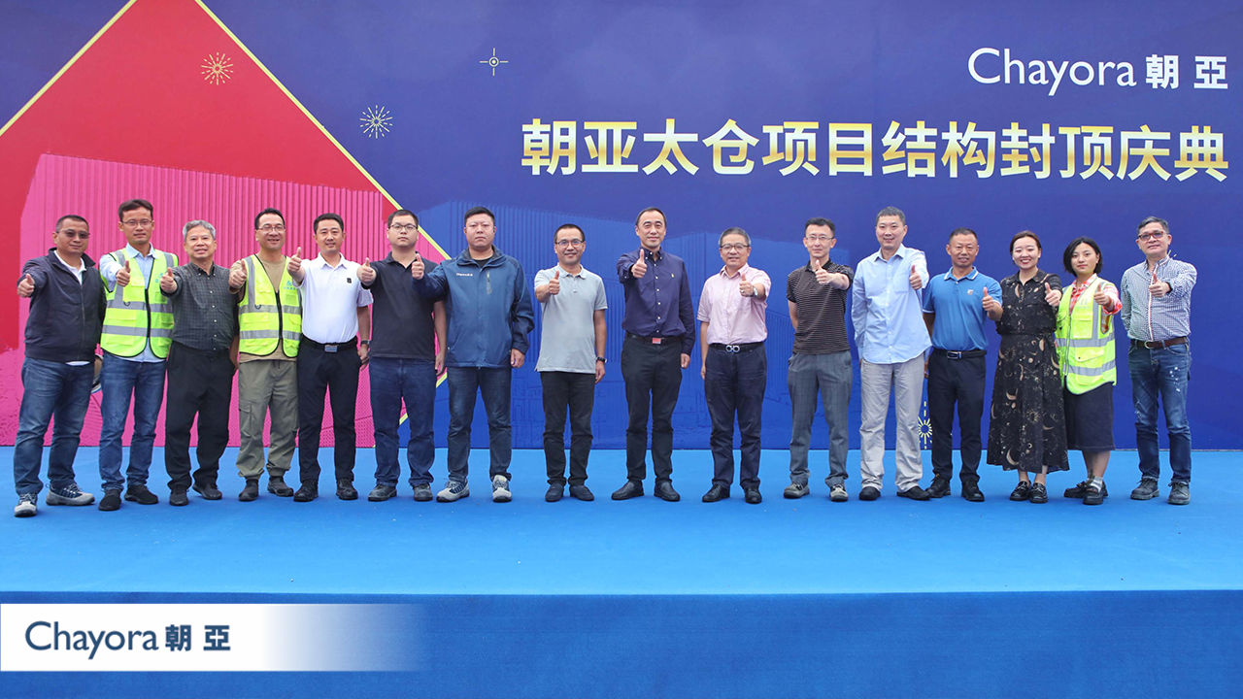

Murray Mo, Project Director responsible for construction of the Shanghai campus, commented “*Although we experienced a very difficult year in 2022 due to continuing Covid restrictions, our project is on track, having completed the upper structure construction as per the original programme. We showed our commitment to Health & Safety with zero incidents or injuries during the construction, achieved 400,000 safe man hours and continue our preparation to hand over for operation in Q1 2023.”*

Mark Froelich, Programme Director, overseeing the safety aspects added *“We recently passed a significant milestone in our ongoing journey towards making Chayora an incident and injury free company when our Shanghai campus SH1 core and shell project passed 400,000 work-hours without a Lost Time Accident. This outstanding achievement confirms Chayora's solid commitment to safety and demonstrates that we ‘walk the talk’ when it comes to safe working practices.”*

More details of the customer event in November and the 2023 Ready for Service launch event will be available soon on www.chayora.com.

# # #

**About Chayora**

Chayora Limited, headquartered in Hong Kong, is wholly-owned by Chayora Holdings Limited, a Cayman Island-based company. Chayora develops hyperscale, world-class designed and operated, scalable data centres and data centre campuses in China. Chayora serves global Fortune 500 companies and premium Chinese data centre operators offering cloud services, ICT services, financial services or other services offerings dependent on intensive, high quality data centre infrastructure in China.

For more information about Chayora, visit [www.chayora.com](http://www.chayora.com).